**Podatki o udeleženki/udeležencu izmenjave**

|  |  |
| --- | --- |
| **Ime in priimek** |  |
| **Oddelek** |  |
| **Telefonska številka** |  |
| **E-pošta** |  |
| **Instagram (če uporabljaš kaj drugega, napiši, kaj in izpolni)** |  |
| **Rojstni datum** |  |
| **Kraj rojstva** |  |
| **Tip (osebna izkaznica, potni list) in številka osebnega dokumenta** |  |
| **Datum izdaje dokumenta** |  |
| **Veljaven do** |  |
| **Telefonska št. staršev** |  |
| **E-pošta staršev** |  |

**Dodatna prtljaga in zavarovanje rizika odpovedi**

1. Leteli bomo z letalsko družbo Transavia in glede prtljage obstaja več možnosti. Prosimo, da pregledate spodnjo tabelo in se odločite. Letos so na novo uvedli tudi nekatere druge pogoje, ki veljajo za posamezne vozovnice, tako da prosimo, da upoštevate tudi to (glejte tabelo). Osnovna cena vozovnice se kot pri vseh letalskih družbah pogosto (včasih tudi dnevno) spreminja, tako da vam cene ne moremo sporočiti, saj so nepredvidljive in odvisne od mnogih faktorjev, na katere nimamo vpliva.

V splošnem velja, da je v osnovno ceno vozovnice (*basic*) vključen le en kos ročne prtljage – t. i. *cabin luggage* (manjši kovček dimenzije 40 x 30 x 20 cm), pri doplačilih (78 evrov oz. 142 evrov – *plus/max*) pa poleg prej omenjenega kosa še prtljaga, ki se jo odda ob prijavi na let (t. i. *hold luggage*).

Za teden dni po navadi zadošča osnovni kos ročne prtljage (*basic*), pogosto pa se dijaki/dijakinje med seboj povežejo (po 2. oz. 3) in skupaj vzamejo en dodaten kos prtljage (*hold luggage*), tako da se strošek potem med njimi porazdeli. Seveda se lahko odločite, da bo dodatni kovček samo od enega posameznika.

Naj spomnimo, da pri ročni prtljagi (ki je vključena v osnovno ceno vozovnice) obstajajo omejitve glede tekočin (max. 100-mililitrska embalaža v skupnem seštevku 1 litra).

Če se odločite za zgolj ročno prtljago (*basic*), upoštevajte, da so strogi glede enega kosa, kar pomeni, da nahrbtnika potniki ne morejo vzeti s sabo (lahko pa ga spakirajo v kovček – ob upoštevanju omejitve kilogramov prtljage).

Spremljevalni profesorji bomo v svojih kovčkih imeli nekaj prostora tudi za kakšno stvar dijakov, če bo to nujno potrebno.

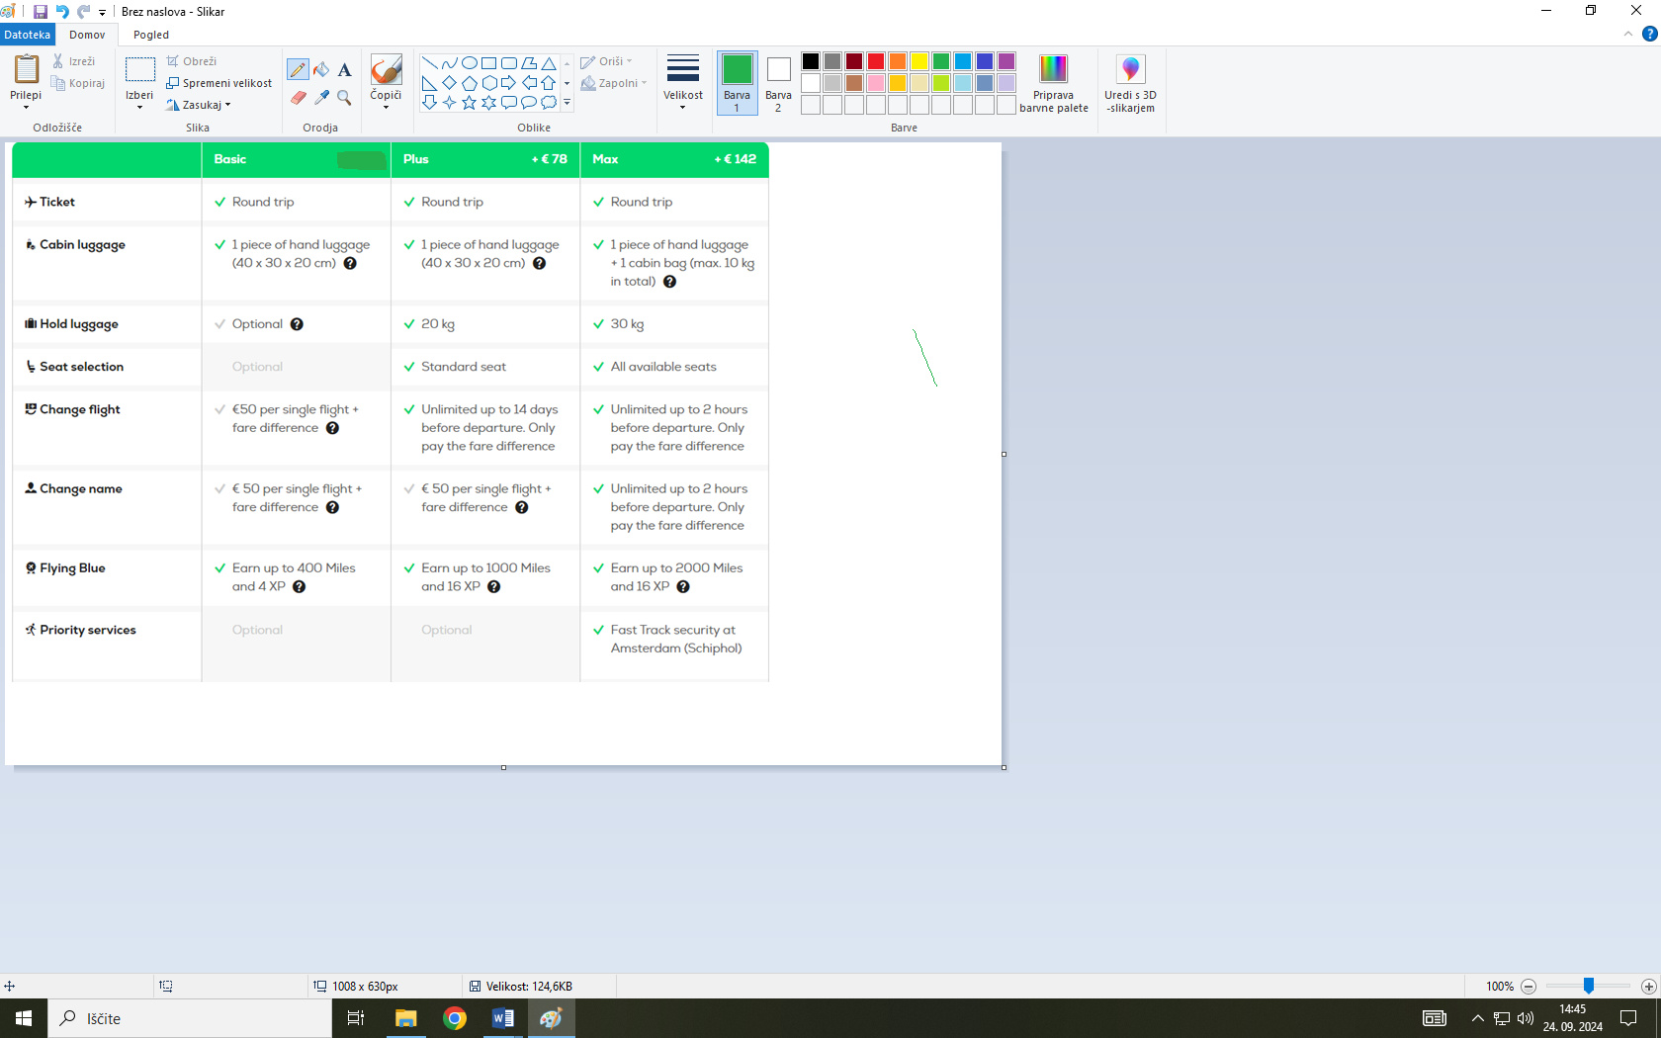

2. Lahko se odločite za **zavarovanje** rizika odpovedi leta, ki velja zgolj v primeru nenadne bolezni oz. določene družinske situacije. Cena je okrog 14 € na osebo (primeru vsaj 10 oseb, ki se zavarujejo). Če se boste za zavarovanje odločili vsi, se cena na osebo lahko zniža, vendar lahko v tem primeru let zaradi bolezni odpove največ 8 oseb.

V spodnji tabeli z X označite, katero dodatno prtljago boste dokupili (če jo seveda boste) in s kom to prtljago delite. Prav tako označite, ali ste se odločili za zavarovanje rizika odpovedi leta. Jasno napišite, ali gre za 20 ali 30 kg dodatne prtljage.

|  |  |
| --- | --- |
| _____ kg | Prtljago delim z/s |
|  |  |

|  |  |
| --- | --- |
| Naročam zavarovanje rizika odpovedi leta |  |

**Soglasje staršev**

Spodaj podpisani/a _________________________________, oče/mati

(ime in priimek)

dijaka/dijakinje ____________________________________________,

(prosim, razen imena in priimka dodajte še letnik in oddelek)

se strinjam, da se moja hči/moj sin v šolskem letu 2024/2025 udeleži izmenjave s srednjo šolo Udens college (Nizozemska). Seznanjen/a sem z okvirnimi stroški in z okvirnim programom izmenjave.

Ljubljana, podpis staršev

dne

STARŠI / DIJAK oz. DIJAKINJA / ŠOLA

POGODBA O POPOLNEM NEUŽIVANJU DROG IN ALKOHOLA

Ime dijaka/dijakinje ____________________________________________ Oddelek __________

Namen te pogodbe je, da sklenemo dogovor o pravilih, ki se nanašajo na uporabo drog in alkohola.

Jaz, ____________________, se strinjam s spodnjimi izjavami:

* Zavedam se, da je uživanje alkoholnih pijač do dopolnjenega 18. leta starosti nelegalno .
* V času šolskih aktivnosti oz. aktivnosti izmenjave ne bom užival-a nobenih alkoholnih pijač (na primer piva, vina, žganih pijač) ali pijač, ki vsebujejo alkohol ali so narejene iz alkohola.
* V času šolskih aktivnosti oz. aktivnosti izmenjave ne bom užival-a nobenih drog.
* Nikoli ne bom sprejel-a ponudbe za prevoz z osebami, ki so ali pa delujejo, da so pod vplivom alkohola ali drog. Raje bom ostal-a tam, kjer sem in poklical-a za prevoz domov.
* Nikoli se ne bom družil-a z osebami, ki bi v času šolskih aktivnosti oz. aktivnosti izmenjave uživale alkohol ali droge.
* Nikoli ne bom pomagal-a drugemu pri nakupu ali prodaji drog ali alkohola.

S spodnjim podpisom se jaz, _________________________, strinjam s temi pravili in zaobljubo, da ne bom užival-a alkohola in drog.

Datum: ____________________ Podpis: ______________________

Dijak/dijakinja: __________________________________________________

Starši oz. skrbniki ___________________________ se strinjamo s temi pravili o popolnem neuživanju alkohola in drog in se ob morebitnih kršitvah popolnoma strinjamo s sankcijami, ki vključujejo predčasni odhod dijaka/dijakinje domov. V tem primeru bomo sami krili stroške letalske vozovnice in ostalih potrebnih prevozov.

Podpis starša/skrbnika 1: Podpis starša/skrbnika 2:

_________________________ _____________________________

Za Gimnazijo Šentvid: ________________________________________________________________

**PARENT / CHILD / SCHOOL**

**0% DRUGS AND ALCOHOL CONTRACT**

Student name *____________________________________________* Class  *__________*

The purpose of this contract is for us to agree on rules pertaining on drug and alcohol behaviour.

I, ______________________, agree to the statements bellow:

* I know that it is illegal for me to drink alcoholic beverages before I am 18 years old.
* I will not drink any alcoholic beverage – for example, beer, wine, hard liquor – or drinks containing or made from alcohol during school and exchange activities.
* I will not use any kind of drugs during school and exchange activities.
* I will never accept a ride with anyone who appears to be under, or is actually under the influence of alcohol or drugs. Instead, I will stay where I am and call for a ride home.
* I will never ‘hang out’ with others while they are using alcohol or drugs during school and exchange activities.
* I will never help someone buy or sell drugs or alcohol.

By signing below, _______________________ agrees on the rules* and pledges to remain alcohol and drugs free.

Date: ______________ Signature:

Student: ___________________________________

We, ______________________________________________, the parents or guardians of

____________________________ agree on these rules and on 0% alcohol and we fully agree that if these rules are not complied, sanctions will follow including being sent home early (should this situation arise) and I/we will cover the cost of the ticket and any other transport necessary.

Signature:

Parent/Guardian 1 Parent/Guardian 2

____________________________ __________________________

On behalf of Gimnazija Šentvid: _______________________________________________________

**Exchange form – type in your answers.**

|  |  |  |  |  |  |  |
| --- | --- | --- | --- | --- | --- | --- |
| **Please add your picture here**  **Name and surname:** | | | | | | |
| **Health information** | | | Specifics | | | |
| **Have you got any allergies?** | | |  | | | |
|  | | |  | | | |
| **Do you take any medication? If so, which?** | | |  | | | |
|  | | |  | | | |
| **Diet** | | | Specifics | | | |
| **Are you a vegetarian/vegan?** | | |  | | | |
|  | | |  | | | |
| **Is there any other necessary dietary information we should know of?** | | |  | | | |
|  | | |  | | | |
| **Language Knowledge** | | | | | | |
|  | **Good** | **Sufficient** | | | **Poor** | **No knowledge** |
| **English** |  |  | | |  |  |
| **Dutch** |  |  | | |  |  |
| **About you** | | | | | | |
|  | | **No preference** | | | **Yes** | **No** |
| **Do you feel at ease in a smoking environment?** | |  | | |  |  |
| **Are you comfortable trying foreign food?** | |  | | | | |
| **The composition of your family (family/household members)** | |  | | | | |
| **Do you have animals at your home?** | |  | | | | |
| **Do you have a problem hosting a partner of the opposite sex?** | |  | | | | |
| **Tell us about your personality and what is important to you in at least 200 words. What are your goals? What are you planning to study? Do you have a life motto that you live by/would like to live by? …** | | | | | | |
| **Tell us about your free time activities and hobbies in at least 200 words.** | | | | | | |
| **Why have you decided to participate in this exchange?** | | | | | | |
| **What do you expect from this exchange?** | | | | | | |
|  | | | |  | | |
| **You are not allowed to drink alcohol - do you and you parents agree with that?** | | | |  | | |
| **Entering the exchange program means:**  **Taking care of your homework, carrying out special assignments and making a personal portfolio - do you agree with that?** | | | |  | | |
|  | | | | | | |
| **Please share other information we should know of.** | | | | | | |
| **Scan your identity card or passport and add the picture, please check the validity date.** | | | | | | |